Project Report

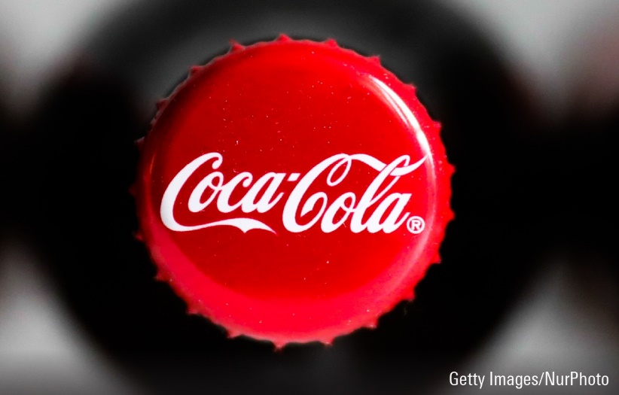

**COCA-COLA**

**BUSINESS ANALYSIS**

**INTRODUCTION**

Coca-Cola is one of the world's leading beverage companies, with a history dating back to 1886 when it was first invented by Dr. John S. Pemberton. Over the years, the company has expanded its product line to include a variety of non-alcoholic beverages, including sparkling drinks, juices, sports drinks, and teas.

Coca-Cola has kept up its expansion and growth over the last 10 years. The business generated $33.01 billion in total sales and $7.38 billion in net profits in 2021. The company's present operations are concentrated on the creation of new goods, market expansion, and funding sustainability programmes.

**HISTORY**

In recent years, the macroeconomic environment in which Coca-Cola works has been characterised by notable instability. The COVID-19 epidemic has significantly impacted the world economy, changing consumer behaviour and disrupting supply chains. Despite these obstacles, Coca-Cola has been able to hold onto its market share and adjust to the shifting business landscape.

Coca-Cola is a leading multinational beverage company that has been in operation for over a century. Over the past ten years, Coca-Cola's stock price has experienced some ups and downs, but has generally performed well in the market. Between 2011 and 2021, the stock price steadily climbed from around $30 per share to a high of $60 per share in early 2020. However, the onset of the COVID-19 pandemic led to a drop in the stock price, which hit a low of around $38 per share in March 2020. Despite this setback, Coca-Cola has shown resilience and has since rebounded strongly. As of March 23, 2023, the stock price of Coca-Cola stands at around $55 per share, indicating a steady upward trajectory. In addition, the company's financial performance has been consistently strong, with a solid balance sheet and healthy revenue growth. Coca-Cola has also continued to innovate and expand its product portfolio to meet the evolving demands of consumers, such as introducing new flavours and investing in healthier beverage options*.*

*PRODUCTS AND COMPETITORS*

The beverage industry is highly competitive, with several major players competing for market share. Coca-Cola's main competitors include PepsiCo, Nestle, Dr. Pepper Snapple, and Keurig Dr. Pepper. According to Statista, in 2021, Coca-Cola had a global market share of approximately 42%, making it the leading player in the industry.

To stay competitive, Coca-Cola has focused on innovation and developing new products. In recent years, the company has launched several new products, including Coca-Cola Zero Sugar, Coca-Cola Energy, and Topo Chico Hard Seltzer. Additionally, Coca-Cola has made a significant investment in sustainability initiatives, with a goal of becoming a net-zero company by 2040.

Overall, Coca-Cola's long history, strong brand recognition, and solid financial performance make it a reliable investment option for those seeking stability and growth potential in their portfolio. While the company may face challenges in the future due to shifting consumer preferences and market trends, its track record of resilience and adaptability suggest that it is well-positioned to weather these changes and continue to thrive in the years to come.

In conclusion, Coca-Cola is a leading global beverage company that has continued to grow and expand its operations in the past ten years. Despite the challenges posed by the macroeconomic environment and the competitive beverage industry, Coca-Cola has managed to maintain its market position through innovation and a focus on sustainability.

**RATIO AND VALUATION ANALYSIS**

Based on the given financial ratios and indicators, the Coca-Cola stock seems to be performing well.

**LIQUIDITY RATIO**

Liquidity ratio is a financial ratio that measures a company's ability to meet its short-term financial obligations. It compares a company's current assets to its current liabilities and helps to determine if the company has enough cash and other assets to pay its bills.

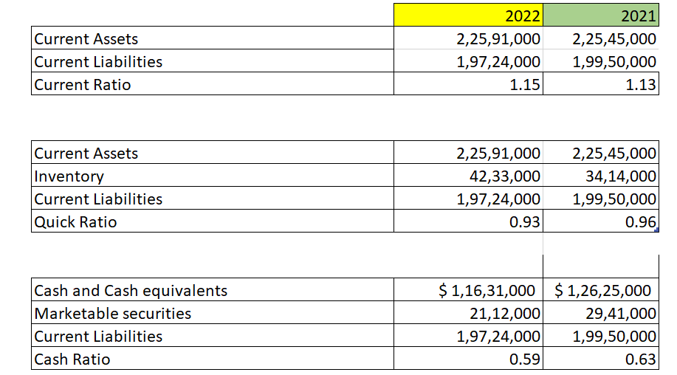

The current ratio of 1.15 and quick ratio of 0.93 indicate that the company has enough current assets to cover its current liabilities, and the cash ratio of 0.59 suggests that the company has enough cash and cash equivalents to pay off its short-term obligations.

**PROFITABILITY RATIO**

Profitability ratios are financial metrics used to assess a company's ability to generate profits in relation to its revenue, assets, or equity. Common profitability ratios include gross profit margin, net profit margin, return on assets (ROA), and return on equity (ROE).

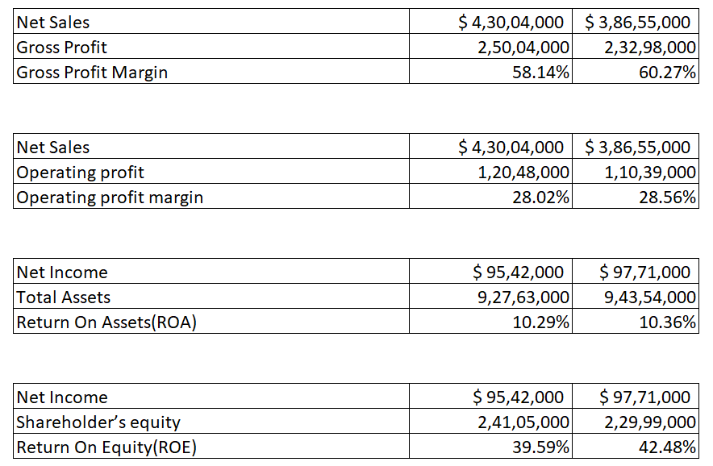

The gross profit margin of 58.14% and operating profit margin of 28.02% are also healthy, indicating that the company is generating a good profit from its sales. Additionally, the return on assets (ROA) of 10.29% and return on equity (ROE) of 39.59% suggest that the company is effectively using its assets and equity to generate profits for its shareholders.

**SOLVENCY RATIO**

Solvency ratio is a financial ratio used to measure a company's ability to meet its long-term financial obligations. It compares a company's total assets to its total liabilities to determine whether it has enough assets to cover its debts.

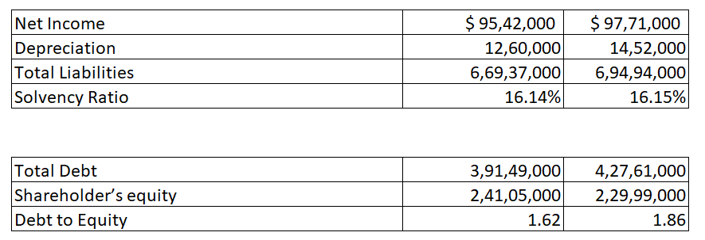

**TURNOVER RATIO**

Turnover ratio in financial analysis refers to the rate at which a company converts its assets into revenue. It is calculated by dividing the cost of goods sold by the average value of inventory or total assets. A high turnover ratio indicates efficient asset utilization, while a low ratio may suggest poor inventory management.

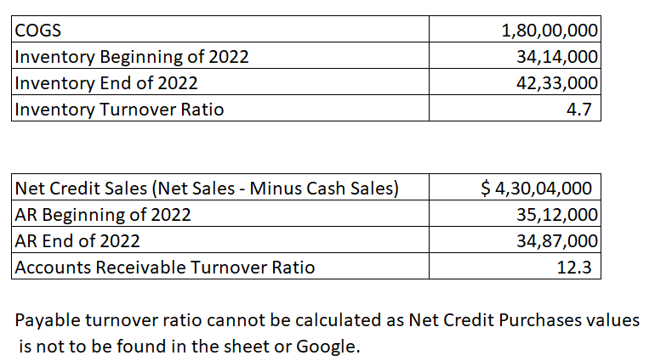

The inventory turnover ratio of 4.7 and accounts receivable turnover ratio of 12.3 also indicate that the company is efficiently managing its inventory and collecting payments from its customers.

The debt to equity ratio of 1.62 suggests that the company has more debt than equity, which may increase financial risk. However, the solvency ratio of 16.14% indicates that the company has enough assets to cover its liabilities.

**EARNING RATIO**

Earnings ratio, also known as price-to-earnings ratio (P/E ratio), is a financial metric used to evaluate a company's stock price relative to its earnings per share (EPS). It helps investors determine the market value of a stock compared to the company's earnings potential.

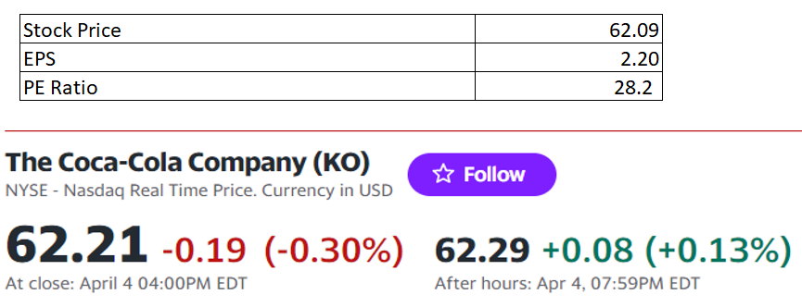

The current price-to-earnings (P/E) ratio of 28.2 suggests that the stock may be slightly overvalued compared to its earnings per share (EPS) of 2.20.

**CAPM Analysis**

The financial model known as CAPM, or capital asset pricing model, is used to calculate the expected return on an investment given its level of risk. The predicted return is calculated by the model using the risk-free rate of return, market risk premium, and asset beta.

The CAPM is significant in company valuation because it aids in estimating the cost of equity capital, which is one of the crucial inputs used to calculate the value of a corporation. This makes it easier for potential investors and buyers to decide whether or not to buy the firm outright.

Formula for CAPM is **Ra = Rf + βa (Rm – Rf)**

Where:

Ra = the required/expected return for the asset/Investment

Rf = the risk-free rate

βa = the beta of the asset/Investment

Rm = the expected market return(market risk premium)

To calculate of KO we used regression analysis in excel to determine beta which is 0.49 and Rm which is 10.33%, the risk free rate(3.3) is extracted from Coca Cola’s financial summary.

Thereafter calculating Ra = 3.3+0.49(10.33-3.3)

Hence the investor can anticipate return of about 17.3% on their investment in Coca-Cola’s stock.

**TECHNICAL ANALYSIS**

**MONTE-CARLO SIMULATION**

Monte Carlo simulations are particularly helpful in finance for option pricing, portfolio optimization, and risk management. They let financial analysts and investors test various hypotheses, gauge the likelihood of certain outcomes, and make better investment decisions.

The below graph is the representation of Frequency VS Daily Return:

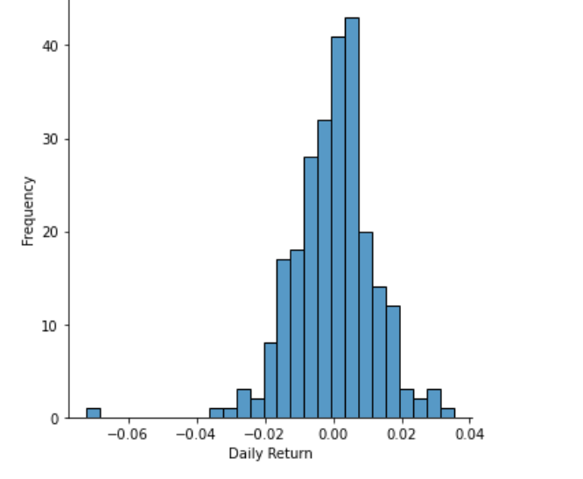

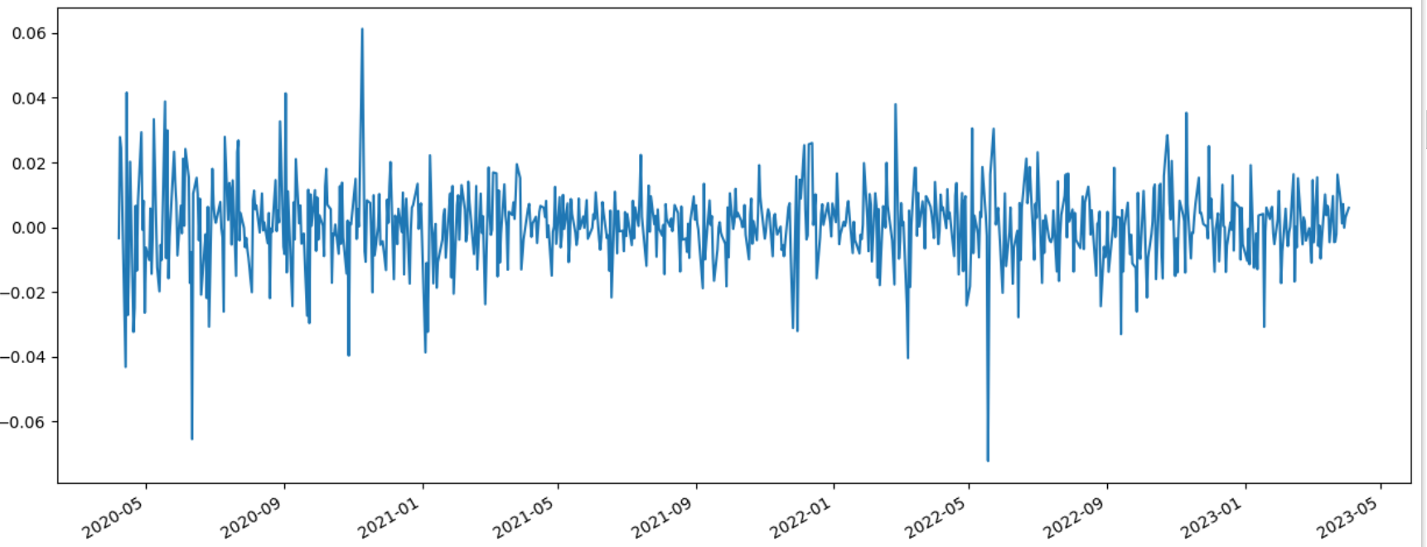

For reference to explain here we have taken data from year 2020:

The above graph shows the adjusted closing price from 2020 to 2023

Monte Carlo simulations involve generating random samples of input variables based on their probability distributions, and then using these inputs to simulate the behaviour of a system over time. The simulation is typically run many times to generate a range of possible outcomes and probabilities for each outcome. By analyzing the results of the simulation, decision-makers can gain insights into the potential risks and rewards associated with different decisions and evaluate the likelihood of achieving specific outcomes. The Monte Carlo method is particularly useful in situations where there is uncertainty and variability in the inputs and where traditional analytical methods may not be practical or effective. As we can see the fluctuations have a wide range in the year 2020 due to the Covid period also the war in Ukraine, persistent inflation, and supply chain hiccups throughout various economic sectors made people nervous due to which we can see the big drop in year 2022 too.

Overall, Monte Carlo simulations offer a mathematical framework for making decisions that considers the inherent unpredictability and uncertainty in complex systems. Decision-makers can take action to minimise risks and maximise rewards by utilising Monte Carlo simulations to better understand the opportunities and possible dangers associated with certain actions.

**MOVING AVAERAGE**

Moving average is an important tool used in financial analysis to smooth out short-term fluctuations in data and provide a clearer picture of the underlying trend. It is widely used in technical analysis to identify trends and potential reversals in financial markets. Moving average can be used to calculate various indicators such as simple moving average, weighted moving average, and exponential moving average. These indicators can help traders and investors to make informed decisions about when to buy or sell securities based on the direction and strength of the trend. Moving average is also useful in forecasting future trends and identifying potential support and resistance levels. Overall, moving average is a versatile tool that can help traders and investors to better understand the dynamics of financial markets and make more informed investment decisions.

Top of Form

**EMA:**

EMA, or Exponential Moving Average, is a commonly used technical analysis tool that helps to identify trends in stock prices. EMA gives more weight to recent prices and is useful in predicting short-term trends. It is important in financial analysis as it can help traders and investors to make informed decisions about when to buy or sell a stock based on its current trend. EMA can also be used in combination with other technical indicators to improve trading strategies.

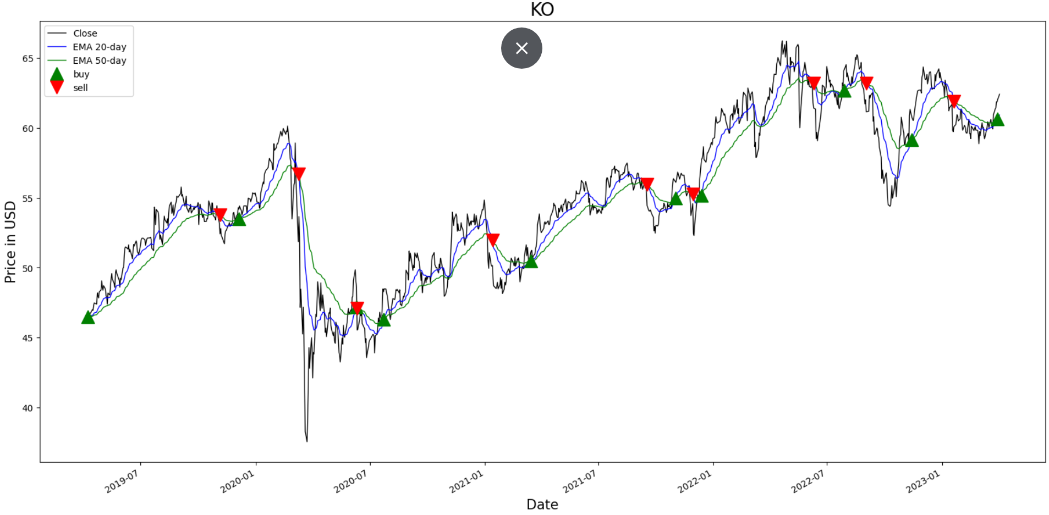

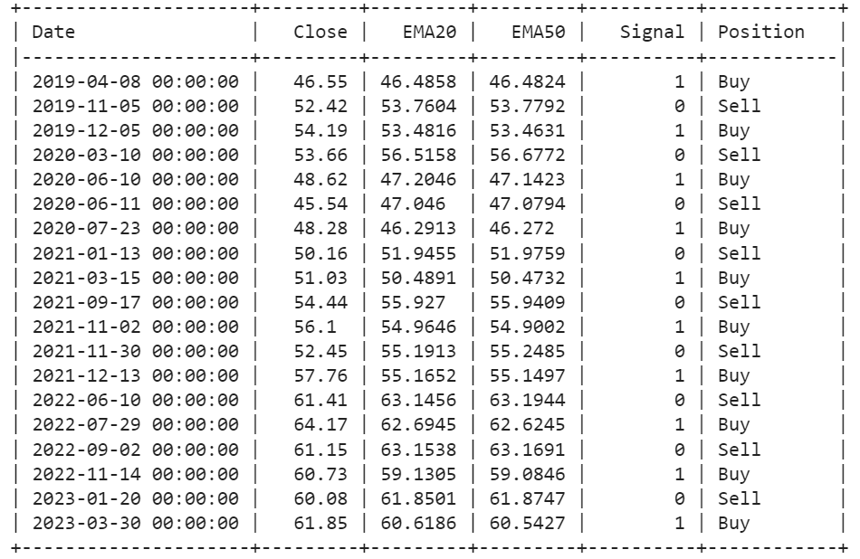

**SMA:**

SMA, or Simple Moving Average, is a popular technical analysis tool used to identify trends and analyze the performance of financial assets. It is important in financial analysis because it can provide insights into the momentum of a stock or market and help traders and investors make informed decisions about when to buy or sell. SMA can also help to identify support and resistance levels, which can be used to set stop-loss orders and limit potential losses.

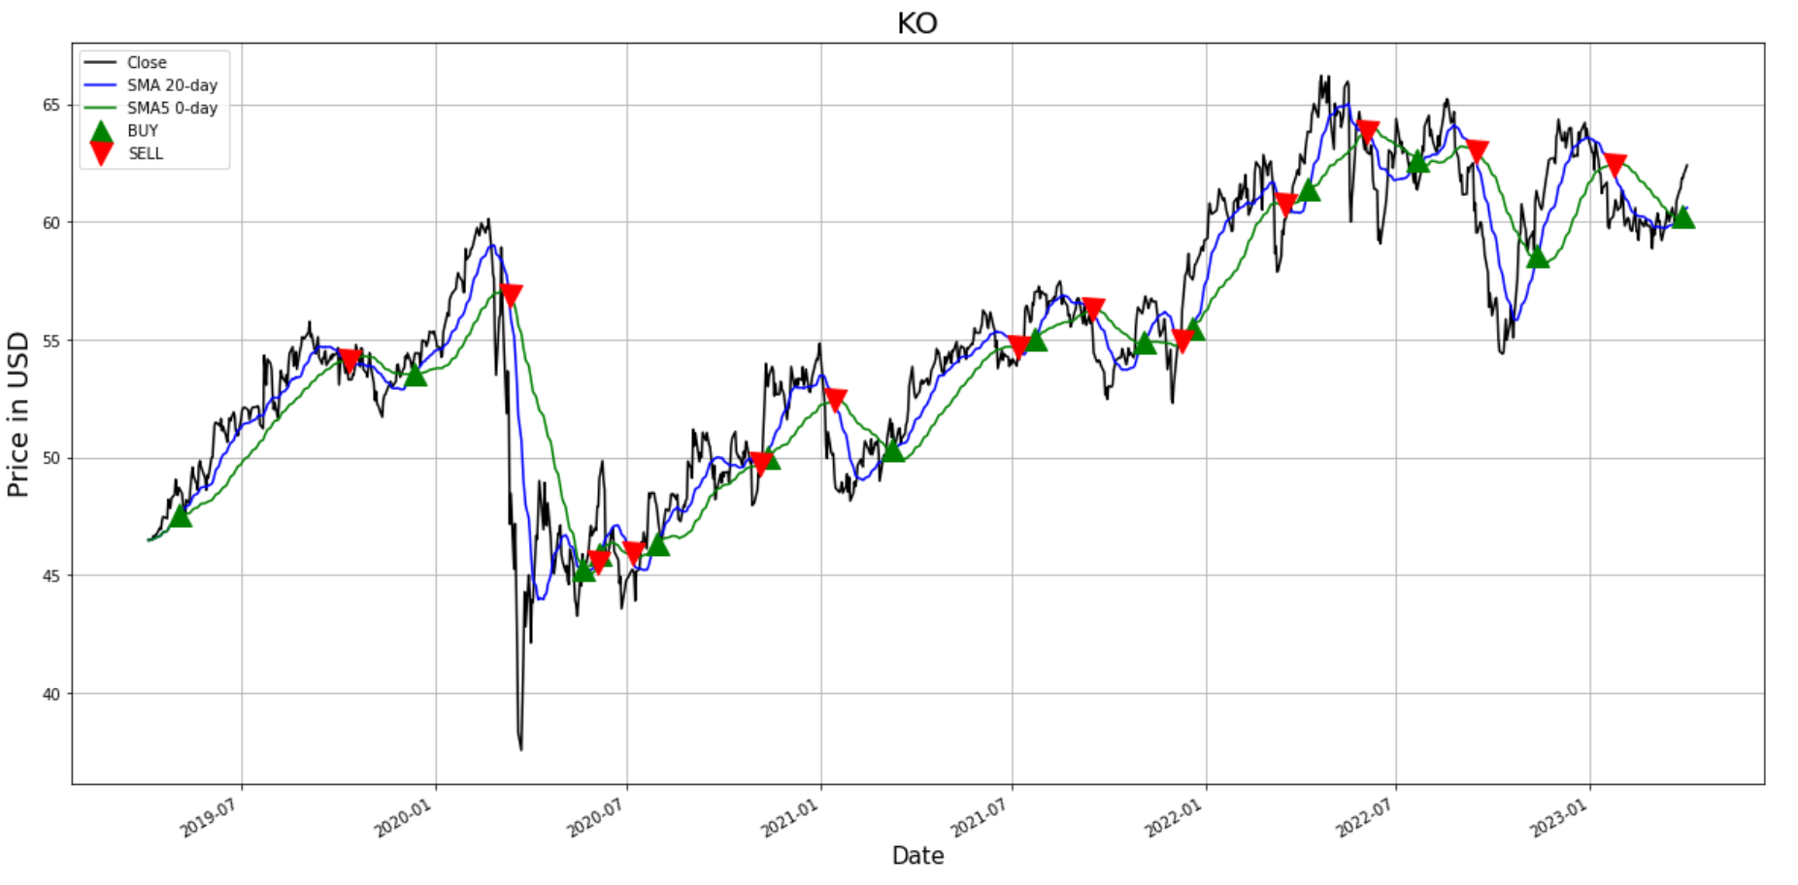

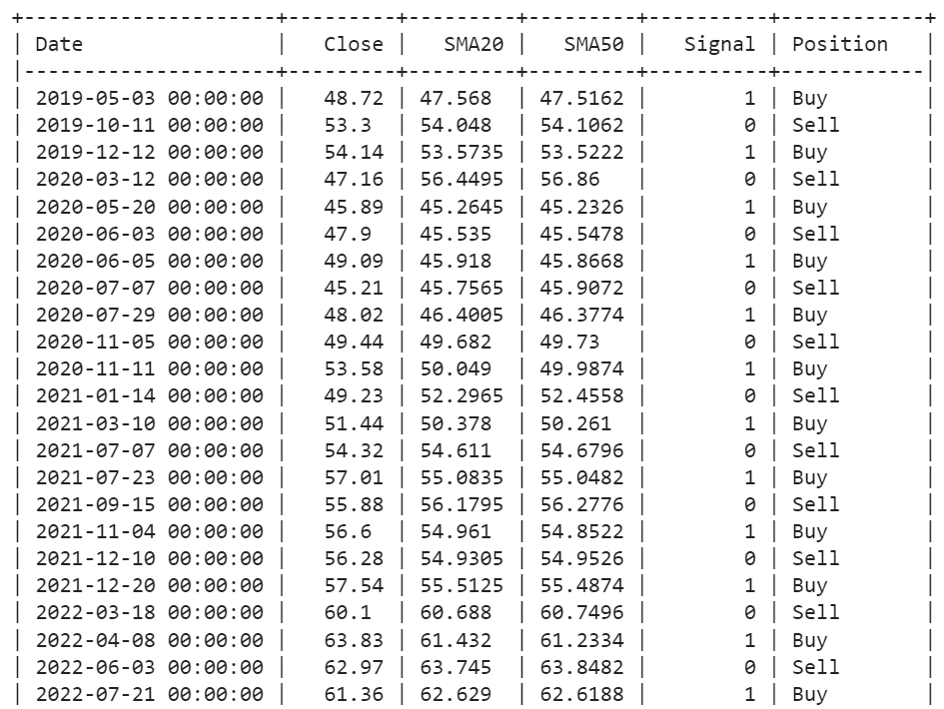

**FACEBOOK PROPHET**

Prophet is a time-series forecasting tool developed by Facebook that uses an additive model to provide highly accurate predictions for various data-driven applications, including financial forecasting. Its importance lies in its ability to handle seasonality, trends, and holidays in data, making it a valuable tool for financial analysts to predict market trends, stock prices, and other financial metrics accurately. Its user-friendly interface and open-source nature also make it accessible and adaptable for various financial analysis needs.

It helps businesses to make informed decisions based on future projections and improve their financial planning, budgeting, and resource allocation.

The graphs generated by Facebook Prophet show the historical trend and seasonality of Coca-Cola's stock price over time, as well as the forecasted trend and seasonality for future periods. The graph may also show any identified turning points in the trend of Coca-Cola's stock price, as well as any potential impacts of external events, such as economic crises or major company announcements.

It is important to note that Facebook Prophet may not account for all factors that could affect Coca-Cola's stock price, such as changes in the overall stock market or unexpected events. Therefore, it is important to use the forecast as a tool for analysis and decision-making, but not rely solely on it for investment decisions.

Here the Prophet’s forecast indicates the increase in the stock price by considering both its trend and seasonality.

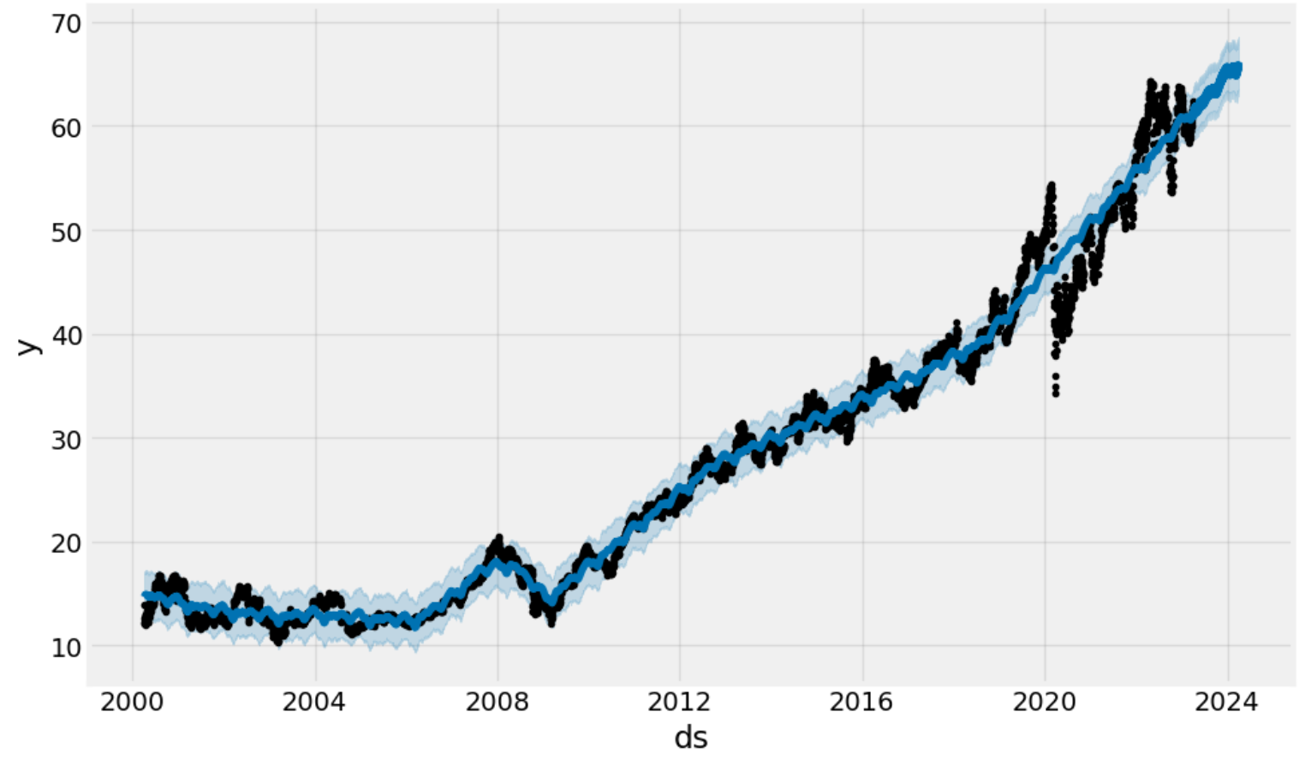

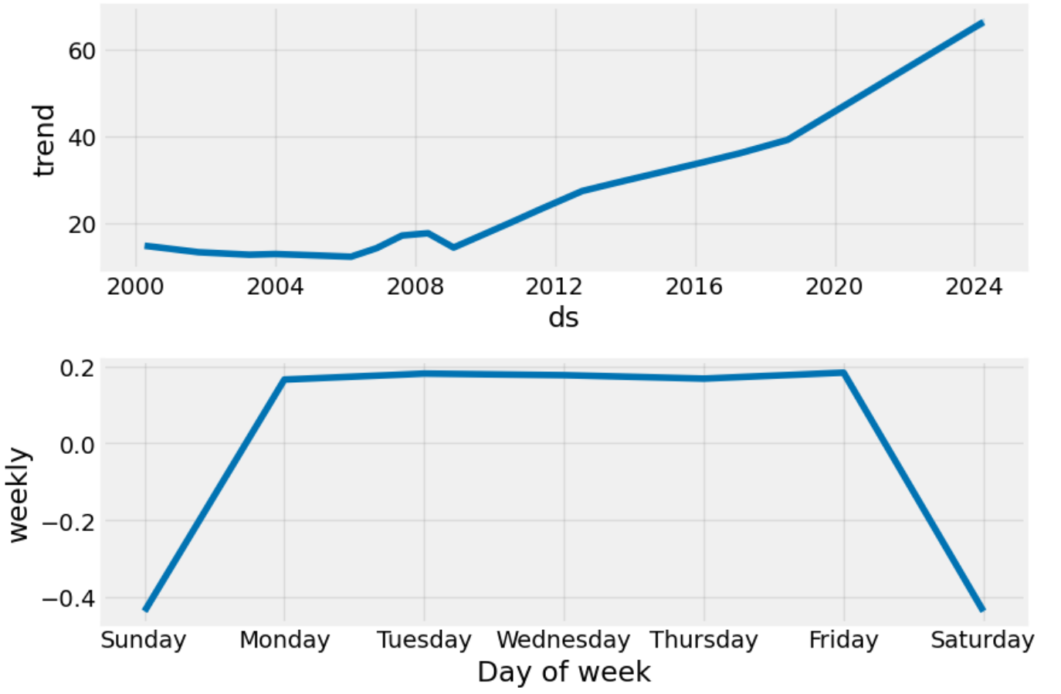

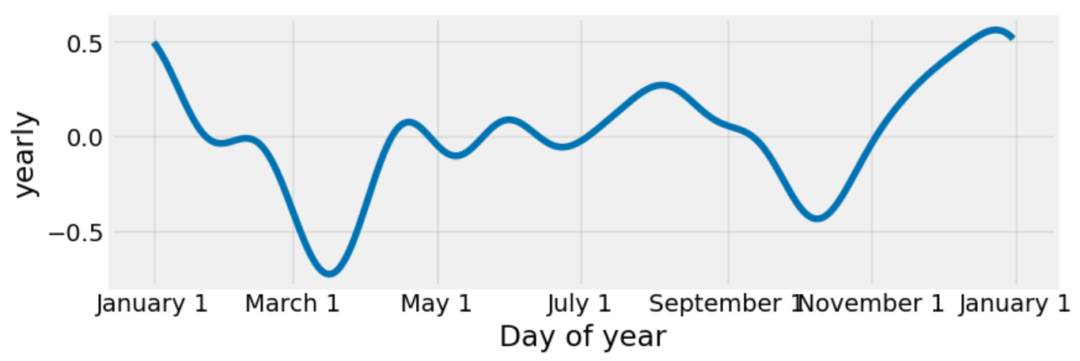

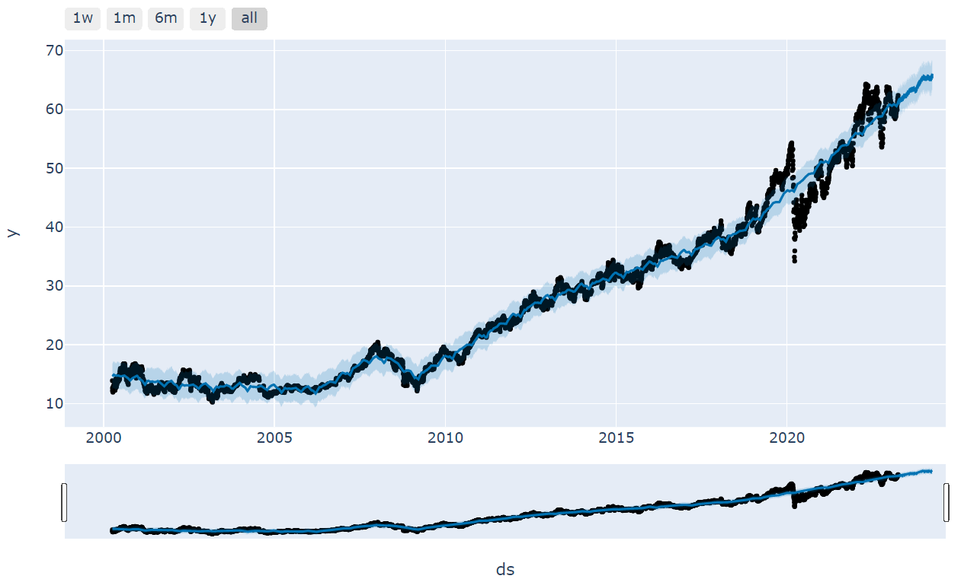

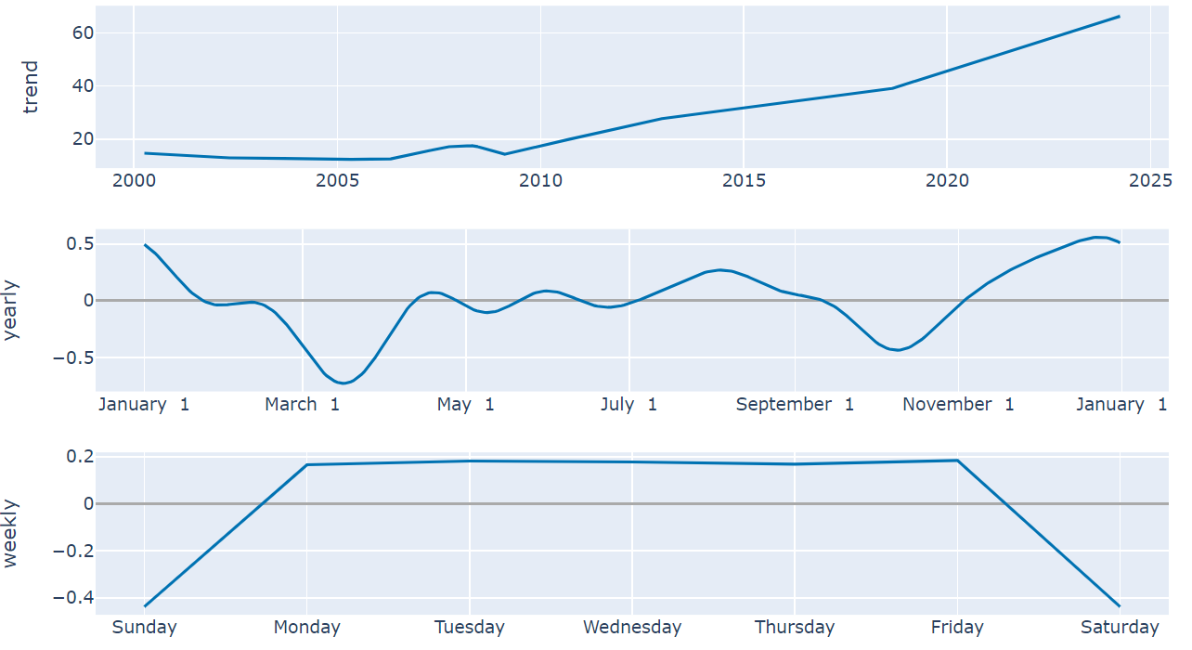

**RECOMMENDATIONS:**

The Coca-Cola firm is a parallel business with light and heavy assets in terms of financial strategy, and this has an impact on how the firm will operate going forward.

However, in recent years, people's awareness of the value of health and the emergence of health consciousness has increased. The beverage sector has seen significant trends in the use of zero sugar and reduced sugar. Additionally, people are developing a resistance to drinks with added sugar.

Coca-Cola might attempt to improve its product line in the future by producing more sugar-free and low-sugar beverages and boosting its spending on environmental budgets and initiatives. Coca-Cola may increase word-of-mouth by, for instance, participating in charitable endeavours and making gifts. c. By leveraging Coca-Cola's brand, a positive impact may be established that will be more beneficial to current business circumstances. By combining the conclusions, it can be said that Coca-Cola is both extremely successful and distinctive.

Investing in Coca-Cola has the potential to generate bigger returns, but doing so also entails taking on a higher degree of risk, according to the different ratios and the findings of the CAPM and Monte Carlo simulations. However, over time, the company's sales, gross profit, and valuation have all steadily increased. As a result, it is clear from the financial analysis that Coca-Cola is a very strong firm with a lot of revenue.

**REFERENCES:**

<https://www.atlantis-press.com/article/125978320.pdf>

<https://www.nasdaq.com/articles/why-coca-colas-stock-popped-as-the-market-lost-its-fizz-in-2022>

<https://finance.yahoo.com/quote/KO/>

[www.google.com/images](http://www.google.com/images)